Career Development

John Wensink

MIS450 Data Mining

Colorado State University-Global Campus

Dr. Steven Chung

6/28/2020

Career Development

For this assignment, I was able to search the online postings for job offerings in the data mining field. A few short weeks ago I wouldn’t have known what some of these jobs entail like USAA’s ETL Engineer which pays $75K - $135K, which would be a welcome raise from the $50k I make currently as a claims adjuster.



Before this class, I wanted to be a database administrator as I’m relatively strong with SQL and physical database arrays. I even have a networked-attached-storage system for my home that uses RAID5 across 4 drives. I would absolutely love to be some sort of data analyst but my math skills are so bad that I don’t think I’d be qualified for the job. I would like to stay with USAA as they have treated me exceptionally well as an employee and there is plenty of room for career advancement there. I am however vested in my 401K so it makes sense to look outside of the organization for career advancement opportunities. Another business that specializes in data analysis is KBR.

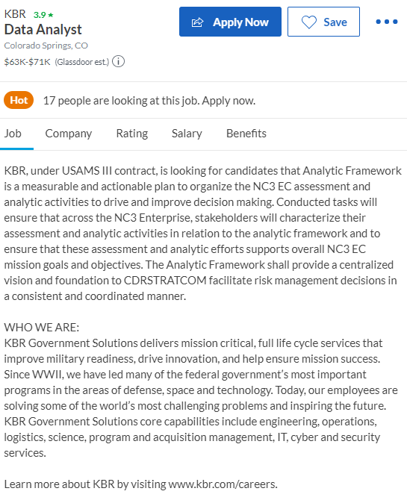

I don’t know what an N3C EC assessment is but this job seems to get high scores on glassdoor and pays well for a career in data analysis.

Another ETL developer job with Young Life looks promising:

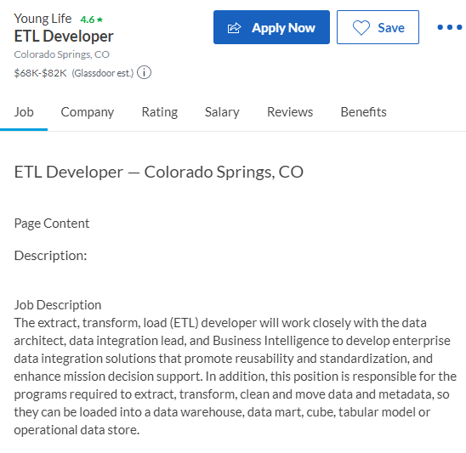

I found Pentaho ETL to be a powerful software that was easy to learn but has so much depth that it would take a lifetime to master. Another posting I found was for Comcast in a data analyst manager role:

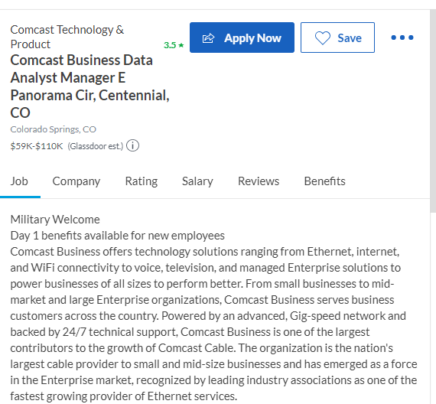

I would like to work my way up the ladder as I grow and learn more skills so that someday I will have a high paying job in the information industry. I do intend to go on to get my master’s degree after I graduate in a few months, and I am hoping I can find a good-paying job so that I can support my family and provide them a comfortable life.